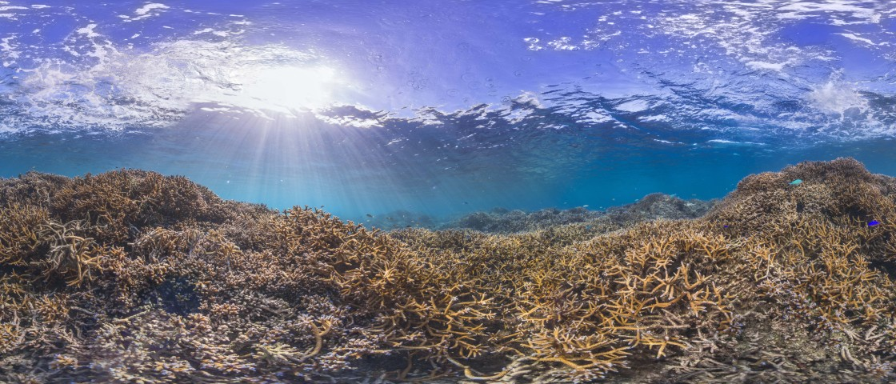

*Image by Stephanie Roach via The Ocean Agency*

***Abstract***

***An individual report by an individual member of Coding Coral group on the analytical process used in investigating the correlation between Climate Change and Coral Resilience in the North Pacific Ocean. The computational programme, Matlab was used in this research.***

***Chua Kai Ting***

***U1640819A***

Coding Corals

***ES2001 Computational Earth Systems Science***

***Project Report***

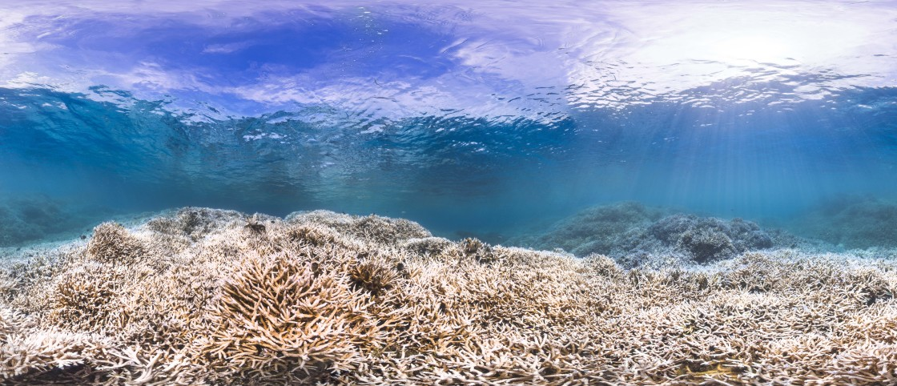

***Image by Stephanie Roach via The Ocean Agency***

## Content Page

Content Page 2

1. Introduction 3

1.1 Background 3

1.2 Scientific Question 3

How resilient are coral reefs in the North Pacific Ocean to climate change? 3

2. Setting the Framework 4

2.1 Regional Setting 4

3. Datasets 4

4. MATLAB Techniques 5

5. Discussion 6

5.1 Timeframe 6

5.2 Preliminary Results and Discussion 7

5.3 Final Discussion and Conclusion 7

6. Limitations 8

6.1 Limitation of Dataset 8

6.2 Other Limitations 8

7. Assumptions 8

Appendix A. 8

Appendix B: Peer Contribution 11

Appendix C: References 12

# **1. Introduction**

## 1.1 Background

Climate Change has caused an increase in sea surface temperature and carbon dioxide emissions (IPCC,2014), the latter causing an increase in ocean acidification (IPCC,2013). There has been extensive evidence of a link between increasing sea surface temperatures and ocean acidification to coral bleaching[1] (Anthony et al.,2008 and McWilliams et al.,2005). Coral Bleaching has shown to lead to an increase in coral mortality and coverage (Loya et al., 2001).

With the following information, the group came up with the following scientific question they would like to investigate on:

## 1.2 Scientific Question

## How resilient are deep sea corals in the North Pacific Ocean to climate change?

We chose the following 7 parameters as indicators of Climate Change; Sea Surface Temperature (SST), Sea Surface Temperature (SST) Anomaly, Ocean Heat Content (OHC), total Carbon Dioxide (CO2) concentration in the sea, Degree Heating Weeks (DHWs), mean seawater pH and bleaching hotspots. These parameters were investigated together with parameters which estimate coral survivability, bleaching severity code, coral population, and coral distribution. As such, the group investigated the above parameters and coral bleaching and hypothesise that climate change has a direct impact on coral population. To add further depth into this research, the different species of coral and their variation in numbers were also analysed to determine if there was variability in their resilience.

# **2. Setting the Framework**

## 2.1 Regional Setting

The region our group chose to work on is the North Pacific Ocean. There are a few reasons why our group decided to use this regional setting. Firstly, we wanted to investigate the hypothesis that reef formation in the North Pacific was difficult due to global climate change and ocean acidification (Baco et al.,2017). The Pacific Ocean has the most number of coral species present **(**Oceanservice.noaa.gov,2017**).** In addition, there are occurrences of mass bleaching event in this ocean which we would like to research on (Coralreefwatch.noaa.gov,2017). We also chose this region because of the many National Marine Sanctuaries and Marine Protected Areas (MPAS) present in the North Pacific (Friends of Midway Atoll National Wildlife Refuge, 2017) which were effective in enhancing coral survivability in the face of climate change in the region. This would help to limit the influence of anthropogenic factors such as overfishing and tourism on the coral reefs, enhancing the focus on Climate Change.

# **3. Datasets**

The following datasets highlighted in yellow were used by Kai Ting.

|  |  |  |  |
| --- | --- | --- | --- |
| Data | Description | Format | Source |
| 1.Sea Surface Temperature (SST)  2. SST Anomaly (SSTA)  3.Degree Heat Weeks (DHW)  4.Hotspots | Different parameters of climate change recorded at various stations located in the North Pacific Ocean | Text file (.txt) | NOAA coral reef Watch virtual Stations |
| Coral species distribution | A list containing the different species of corals and their corresponding location in the North Pacific Ocean. | Comma separated variables (.csv) | NOAA Deep Sea Coral database |
| Ocean heat content | Yearly global ocean heat content  Independently calculated lines from 3 governmental agencies. | Comma separated variables (.csv) | NOAA,CSIRO and MRI/JMA |
| 1.SST max  2.SST anomaly min, max, mean 3.Hotspot max, 4.DHW max | Annual Composites  of Twice-Weekly 50-km Satellite Coral Bleaching Monitoring Products | Hierarchical data format (.hdf) | NOAA Satellite and Information Service |
| Hawaii Ocean Time-Series (HOT) surface CO2 system data product | Extracted mean seawater salinity normalized Dissolved Inorganic Carbon (=total CO2 concentration) and mean seawater pH | Textfile (.txt) | Hawaii Ocean Time-series (HOT) program |

*Table 1. Datasets use with brief description, format and source*

# **4. MATLAB Techniques**

|  |  |  |
| --- | --- | --- |
| NOAA Deep Sea Coral database | | |
| Challenges | | Solutions |
| 1. | Individual Counts of Coral Species contained many  -999 values, appearing much more than normal individual count values | The individual counts of the Corals were not downloaded. Instead only Vernacular Name Category and Vernacular Name data was downloaded. Used number of Coral Records as a proxy for Coral population instead of individual counts. |
| 2. | Individual Counts of Coral Species were saved as yearly data in 16 different .csv files | Created a ***for loop*** to loop through all 16 years from 2000 to 2015. To read all the files in the loop, concatenate the filename, path and year in the loop to a single string. Converted the year number to a character array using the function ***num2str*** so it can be concatenated |
| 3. | Summing up the Coral Records based on the length of each name category of the coral | Calculated the total number of coral records for each species (based on name cat) for each year. Used ***length*** to find this. Appended the yearly values into a vector opened before the for loop. |
| Calculating Correlation Values | | |
| 1. | Values of the 7 parameters for correlation were stored in variables when the script reading the data were ran | Use the function ***csvwrite*** to write a comma-separated value file. Use the function ***textread*** to read the new csv files for each parameter |
| 2. | Timeframe for the parameters were different. Same time frame needs to be used for correlation | Use a ***for*** loop to loop through the years in the data, ***append*** the years from 2000 to 2015. Find the values of the data which corresponds to the index of the years being looped. Append these values to a vector. |
| Analysis of Coral Record Graph | | |
| 1. | Setting the parameters for the ***if*** loop to loop through the years and extract the years where there was a decrease in coral records in the subsequent year | Set the ***if*** loop years from 1 to the length of (coral record-1) year. For the ***if*** conditional statement, (n+1) year will be used so the largest n value extracted out plus one would coincide with the last year where there are coral records. This could be done by trial and error and seeing which years matches the years on the graph where there was a decrease in coral records |

*Table 2. Information showing the challenges faced and solutions taken*

# **5. Discussion**

## 5.1 Timeframe

Global Climate Models have shown that the thermal thresholds of corals will be exceeded more frequently as Climate Change exacerbates thus causing bleaching events to occur more frequently (IPCC,2007). Thus, our group decided to focus on years after the from the 21st century. This would also allow us to have a more in-depth analysis based on certain time periods in this timeframe where there were major climatic events and investigate Coral resilience to Climate Change based on recent years.

## 5.2 Preliminary Results and Discussion

The plot of coral records over time shows a general reduction in coral records from 2000 to 2015. There was a total of 8 fluctuations in coral records. The most drastic coral reductions occurred in the years of 2010 to 2013. This coincides with the mass global reaching event which occurred in 2010 (Gaskill,2010). We chose to investigate the resilience of certain species of corals based on the years from 2010 to 2013 and from 2014 onwards. This is because we want to investigate the resilience of corals after a major bleaching event and its ability to recover during the next bleaching event.

My results have showed that between coral records and the 7 parameters we are investigating, there was a positive correlation with Sea Surface Temperature (SST), SST anomaly, CO2 concentration, hotspots and degree heating weeks data. There is a positive correlation with pH levels and ocean heat content (Fig 4.) Except for Ocean Heat Content, all other climate change indicators support the group’s hypothesis. This observation supports our hypothesis that climate change has a direct impact on coral population.

## 5.3 Final Discussion and Conclusion

Analysis from correlating climate change indicators to coral population showed a high likelihood that worsening climate change will lead to coral bleaching and coral deaths. From which, there are drastic reduction in coral population in years 2010 and 2014. We investigated if there were varying levels of resilience between different species of corals during these time periods. Sponges are most likely most resilient to climate change, followed by Black Corals with the least resilient to Climate Change being Soft Corals and Demosponges. Glass sponges and Gorgonian sponges displayed a growing resilience to climate change as these corals can adapt to more extreme conditions. Finally, the sea pens are the most likely the most resilient species as they experience an increased in population in both bleaching events.

# **6. Limitations**

## 6.1 Limitation of Dataset

Most of our datasets are presented yearly thus they do not account for Monthly, Weekly and daily fluctuations and other changes such as seasonality. Thus, there may be cyclicities not accounted for in our analysis. Due to most of our datasets being presented yearly, we chose to research by year even for datasets that were presented otherwise.

Climate Change is a multi-faceted issue which affects many different parameters which may also play a role in determining coral bleaching and ability to survive. Therefore, it is challenging to consider too many variables even though this analysis might give a more complete picture and could be used for further investigation.

## 6.2 Other Limitations

Disentangling the impacts of stress that are related to climate change from other stresses such as over-fishing and pollution is difficult (Hughes et al., 2003). These stresses are likely to influence coral population and survivability as well.

# **7. Assumptions**

We used the number of coral records as a proxy for the coral population. A decrease in number of coral records represents a decrease in coral population.

To answer our scientific question, our group assumes that the parameters indicative of climate change is Sea Surface temperatures (SST) and their anomalies, Ocean Heat Content (OHC), CO2 concentration and pH levels. These in turn causes increases in hotspots and degree heating weeks, resulting in coral bleaching and a reduction in coral population.

# **Image result for north pacific ocean mapAppendix A.**

*Fig 1. Map of North Pacific Ocean (Regional Setting)*

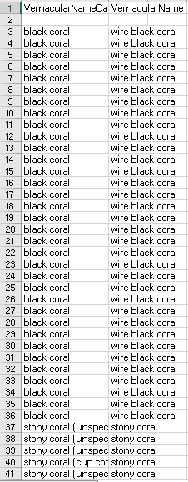

*Fig 2. Part of Yearly Coral Record data*

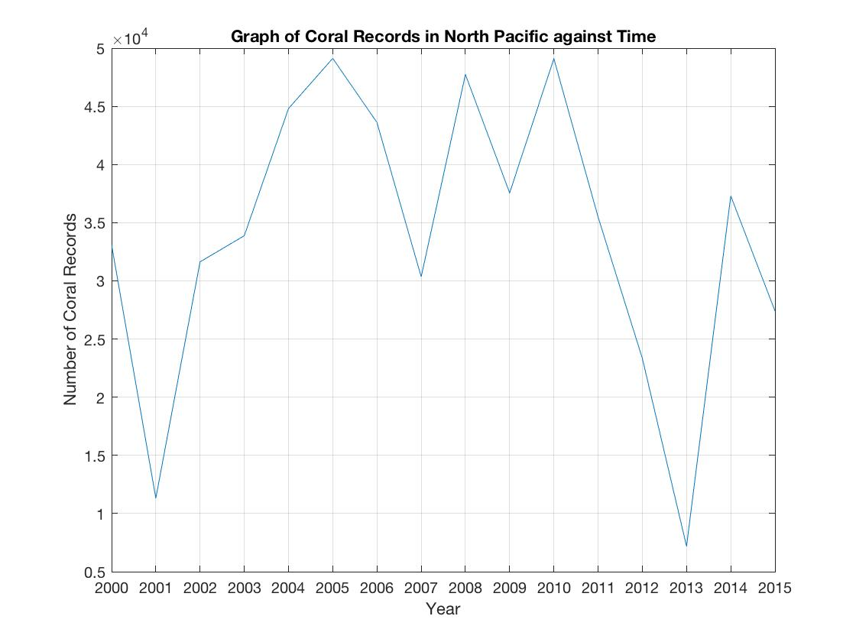 *Fig3. Plot of Total Coral Records in the North Pacific against Years*

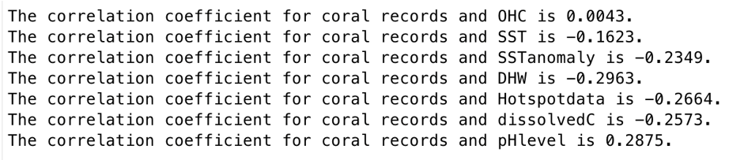

*Fig 4. Correlation values between coral records and the parameters*

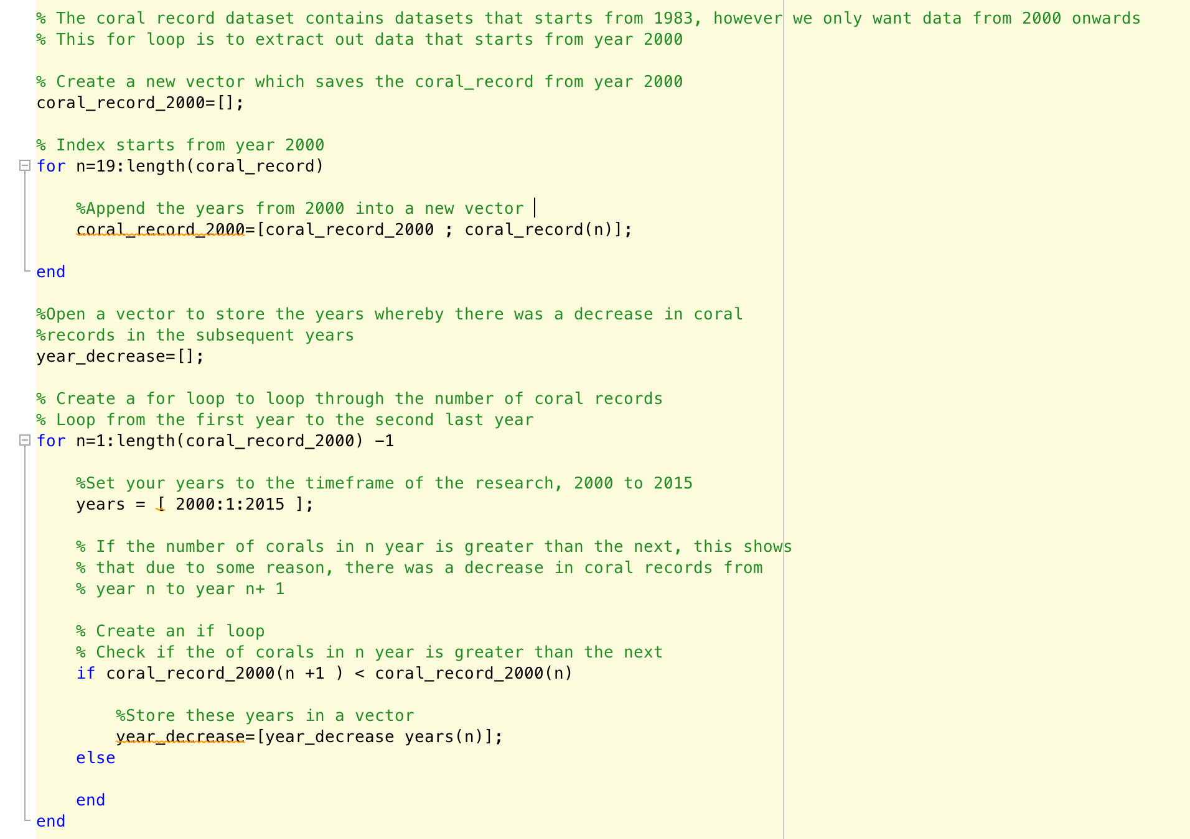

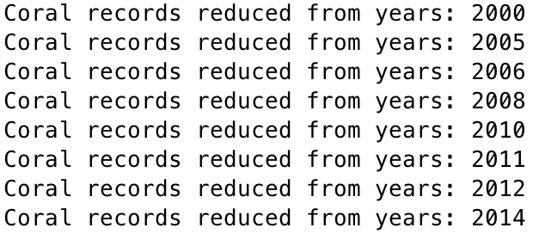*Fig 5. Script to extract out the years whereby there was a decrease in coral records as compared to the subsequent year*

*Fig 6. Years whereby there was a decrease in Coral records*

# **Appendix B: Peer Contribution**

|  |  |
| --- | --- |
| Nicholas | 1. Sourcing data for ocean heat content 2. Obtaining yearly coral population data 3. Find the years where there is decrease in coral records 4. Calculating yearly sea surface temperature, sea surface temperature anomaly, dissolved inorganic carbon and pH levels 5. Plotting the above datasets, along with DHW and hotspot data into figures and analyzing them 6. Creating functions to read the coral and bleaching dataset (with help from Reynold and Ze Ming) 7. Final analysis for project |
| Skye | 1. Sourcing & downloading coral distribution data 2. Calculating and plotting individual coral species records across time 3. Plotting yearly coral distribution by color 4. Plotting histograms of coral species by year 5. Final analysis 6. Created a function and cleaning up scripts to make Nicholas’ script more efficient 7. Plotting linear best-fit line for OHC 8. Helped Reynold organise data to plot SST, SST anomaly, DHW Hotspot data in North Pacific Region on a map. |
| Kai Ting | 1. Obtaining yearly coral population data 2. Calculating the correlation between coral records and yearly sea surface temperature (SST), SST anomaly, dissolved inorganic carbon (nDIC), pH levels 3. Plotting the above datasets into figures and analyzing them 4. Analysing the Coral Records graph and extracting out the years where bleaching occurred 5. Final analysis |
| Ze Ming | 1. Sourcing for DHW, SST, SST anomaly, Hotspot data in North Pacific region 2. Source for CO2 and pH data in North Pacific Region 3. Calculating and plotting individual coral species records across time 4. Data conversion and extraction for coral species distribution 5. Calculating yearly DHW and hotspot data 6. Plotting histogram to show annual coral distribution among different species 7. Final analysis |
| Reynold | 1. Analysing degree of bleaching in North Pacific by plotting stations with recorded bleaching severity code on a map. 2. Analysing interpolated probability of bleaching occurrence between 1985 to 2010. 3. Helped Ze Ming plot SST, SST anomaly, DHW, Hotspot data on a map obtained from NOAA Coral Reef Watch Virtual Stations for each year. 4. Assisted in reading the dissolved inorganic carbon and pH levels data into MATLAB 5. Assisted in loading data of coral distribution into MATLAB. 6. Analyzing the final figures and drawing conclusions. 7. Final analysis |

# **Appendix C: References**

1. IPCC, 2014: Climate Change 2014: Synthesis Report. Contribution of Working Groups I, II and III to the Fifth Assessment Report of the Intergovernmental Panel on Climate Change [Core Writing Team, R.K. Pachauri and L.A. Meyer (eds.)]. IPCC, Geneva, Switzerland, 151 pp.
2. IPCC, 2013: Summary for Policymakers. In: Climate Change 2013: The Physical Science Basis. Contribution of Working Group I to the Fifth Assessment Report of the Intergovernmental Panel on Climate Change [Stocker, T.F., D. Qin, G.-K. Plattner, M. Tignor, S. K. Allen, J. Boschung, A. Nauels, Y. Xia, V. Bex and P.M. Midgley (eds.)]. Cambridge University Press, Cambridge, United Kingdom and New York, NY, USA.
3. Anthony, K., Kline, D., Diaz-Pulido, G., Dove, S. and Hoegh-Guldberg, O. (2008). Ocean acidification causes bleaching and productivity loss in coral reef builders. *Proceedings of the National Academy of Sciences*, 105(45), pp.17442-17446.
4. McWilliams, J., Côté, I., Gill, J., Sutherland, W. and Watkinson, A. (2005). ACCELERATING IMPACTS OF TEMPERATURE-INDUCED CORAL BLEACHING IN THE CARIBBEAN. *Ecology*, 86(8), pp.2055-2060.
5. Loya, Y., Sakai, K., Yamazato, K., Nakano, Y., Sambali, H. and van Woesik, R. (2001). Coral bleaching: the winners and the losers. *Ecology Letters*, 4(2), pp.122-131.
6. Baco, A., Morgan, N., Roark, E., Silva, M., Shamberger, K. and Miller, K. (2017). Defying Dissolution: Discovery of Deep-Sea Scleractinian Coral Reefs in the North Pacific. *Scientific Reports*, 7(1).
7. Oceanservice.noaa.gov. (2017). *What ocean basin has the most corals?*. [online] Available at: https://oceanservice.noaa.gov/facts/most_coral.html [Accessed 9 Nov. 2017]
8. Coralreefwatch.noaa.gov. (2017). Global Coral Bleaching 2014-2017: Status and an Appeal for Observations. [online] Available at: https://coralreefwatch.noaa.gov/satellite/analyses_guidance/global_coral_bleaching_2014-17_status.php [Accessed 10 Nov. 2017].
9. Friends of Midway Atoll National Wildlife Refuge. (2017). *Pacific Ocean MPAs*. [online] Available at: https://www.friendsofmidway.org/pacific-ocean-mpas/ [Accessed 9 Nov. 2017].
10. Gaskill, M. (2010). Coral bleaching goes from bad to worse. *Nature*.
11. IPCC, 2007: Climate Change 2007: Impacts, Adaptation and Vulnerability. Contribution of Working Group II to the Fourth Assessment Report of the Intergovernmental Panel on Climate Change, M.L. Parry, O.F. Canziani, J.P. Palutikof, P.J. van der Linden and C.E. Hanson, Eds., Cambridge University Press, Cambridge, UK, 976pp.
12. Hughes, T. (2003). Climate Change, Human Impacts, and the Resilience of Coral Reefs. *Science*, 301(5635), pp.929-933.

1. Whitening of corals because of the expulsion of symbiotic zooxanthellae brought about by stressors in the environment